stepper motor

Connect the black wire with 1B, the yellow wire with 1A, the second yellow wire with 2A, the red wire with 2B, GND with the right negative of the capacitor, Vmot with 12v, VDD with 5v, GND with GND of Arduino, SETEP with pin (11) and DIR with pin(10)

and SLEEP with RESE

Servo motor

Brown to GND, Red to 5v, and Yellow to pin(3)

IR Sensor1

pin2 to GND, pin1 to 5v, and pin3 to pin(12)

IR Sensor2

pin2 to GND, pin1 to 5v, and pin3 to pin(13)

DC Motor1

Connect the positive wire to 12v power and the negative wire to the right outlet of Relay module GND of 12v power to the middle outlet of relay module on the upper side

And on the lower side

entries

The first input is connected with 5v

The second input is with GND and the third input is with pin(2)

DC Motor2

Connect the positive wire to 12v power and the negative wire to the right outlet of Relay module GND of 12v power to the middle outlet of relay module on the upper side

And on the lower side

entries

The first input is connected with 5v

The second input is with GND and the third input is with pin(5)

Water pump

Connect the positive wire to 12v power and the negative wire to the right outlet of Relay module GND of 12v power to the middle outlet of relay module on the upper side

And on the lower side

entries

The first input is connected with 5v

The second input is with GND and the third input is with pin(4)

Air pump

Connect the positive wire to 12v power and the negative wire to the right outlet of Relay module GND of 12v power to the middle outlet of relay module on the upper side

And on the lower side

entries

The first input is connected with 5v

The second input is with GND and the third input is with pin(7)

Connect of Relay module

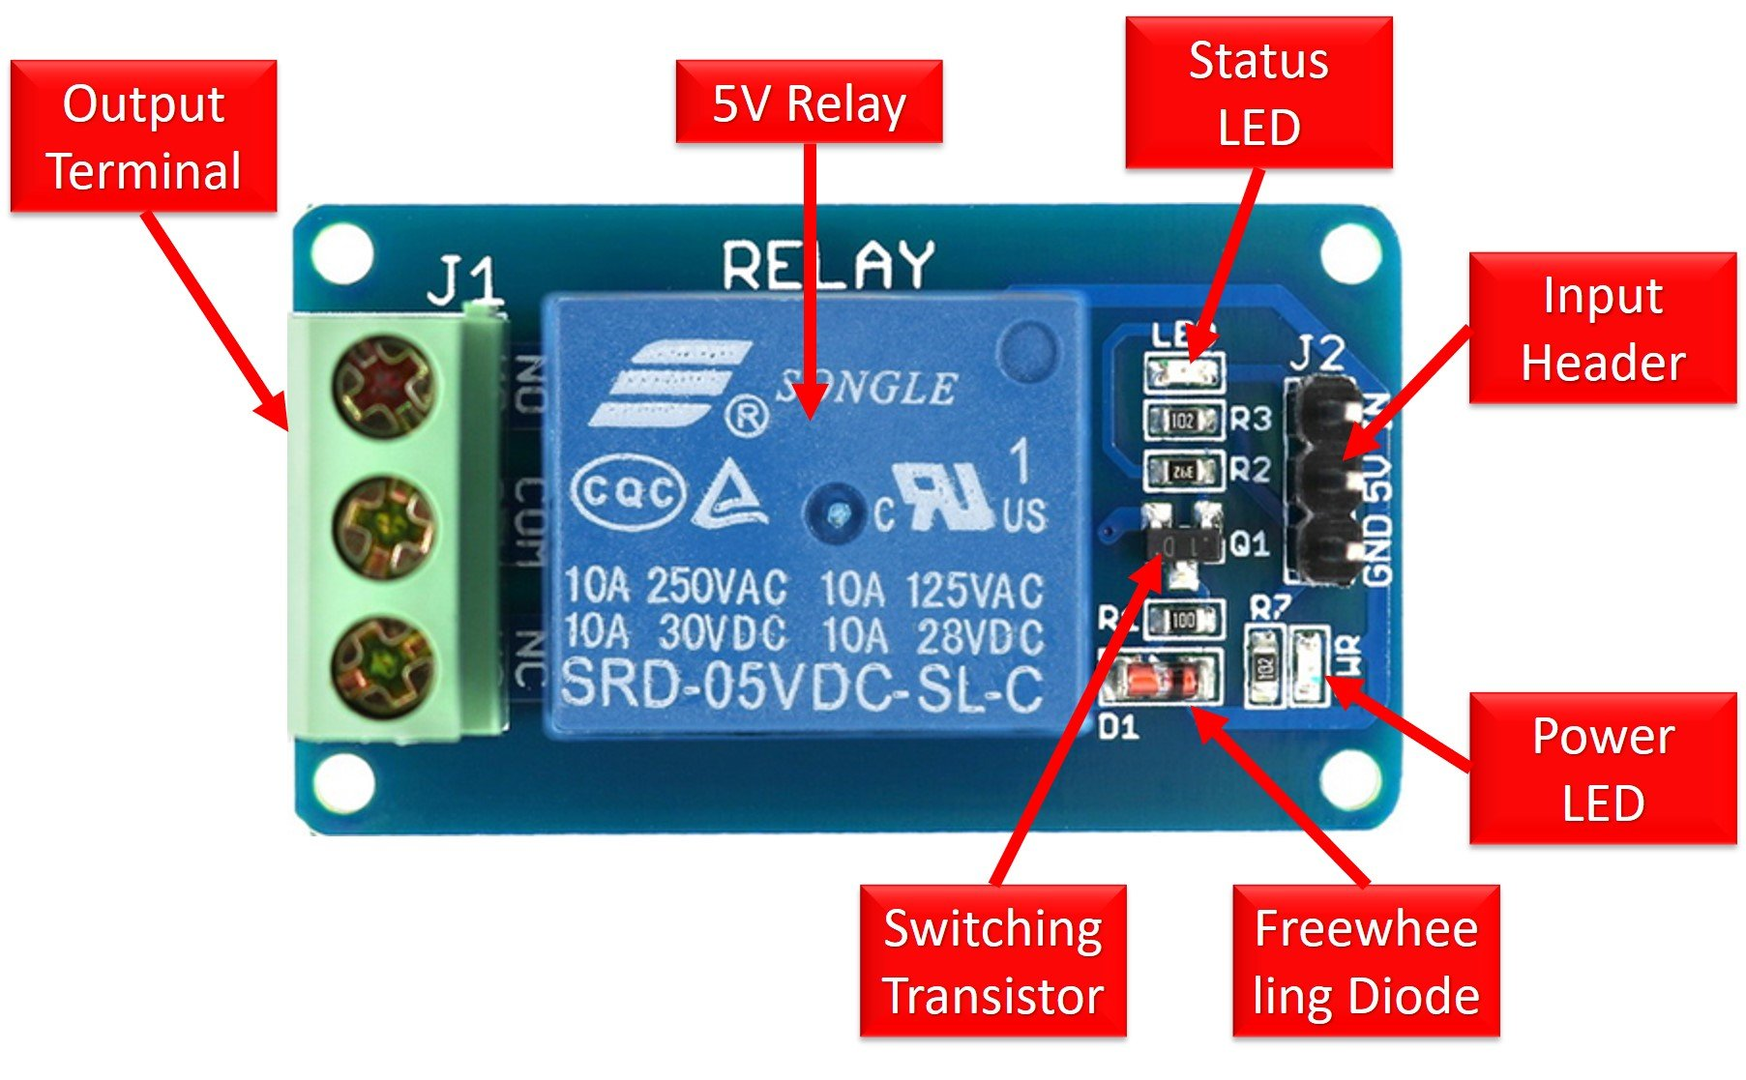

(DC motor 1 , DC motor 2 , Water pump , Air pump ) Connect with 12v power

)IR sensor 1, IR sensor2 , 4 Relay module , servo motor) Connect with 5v of Arduino

All components are connects with the same (GND)